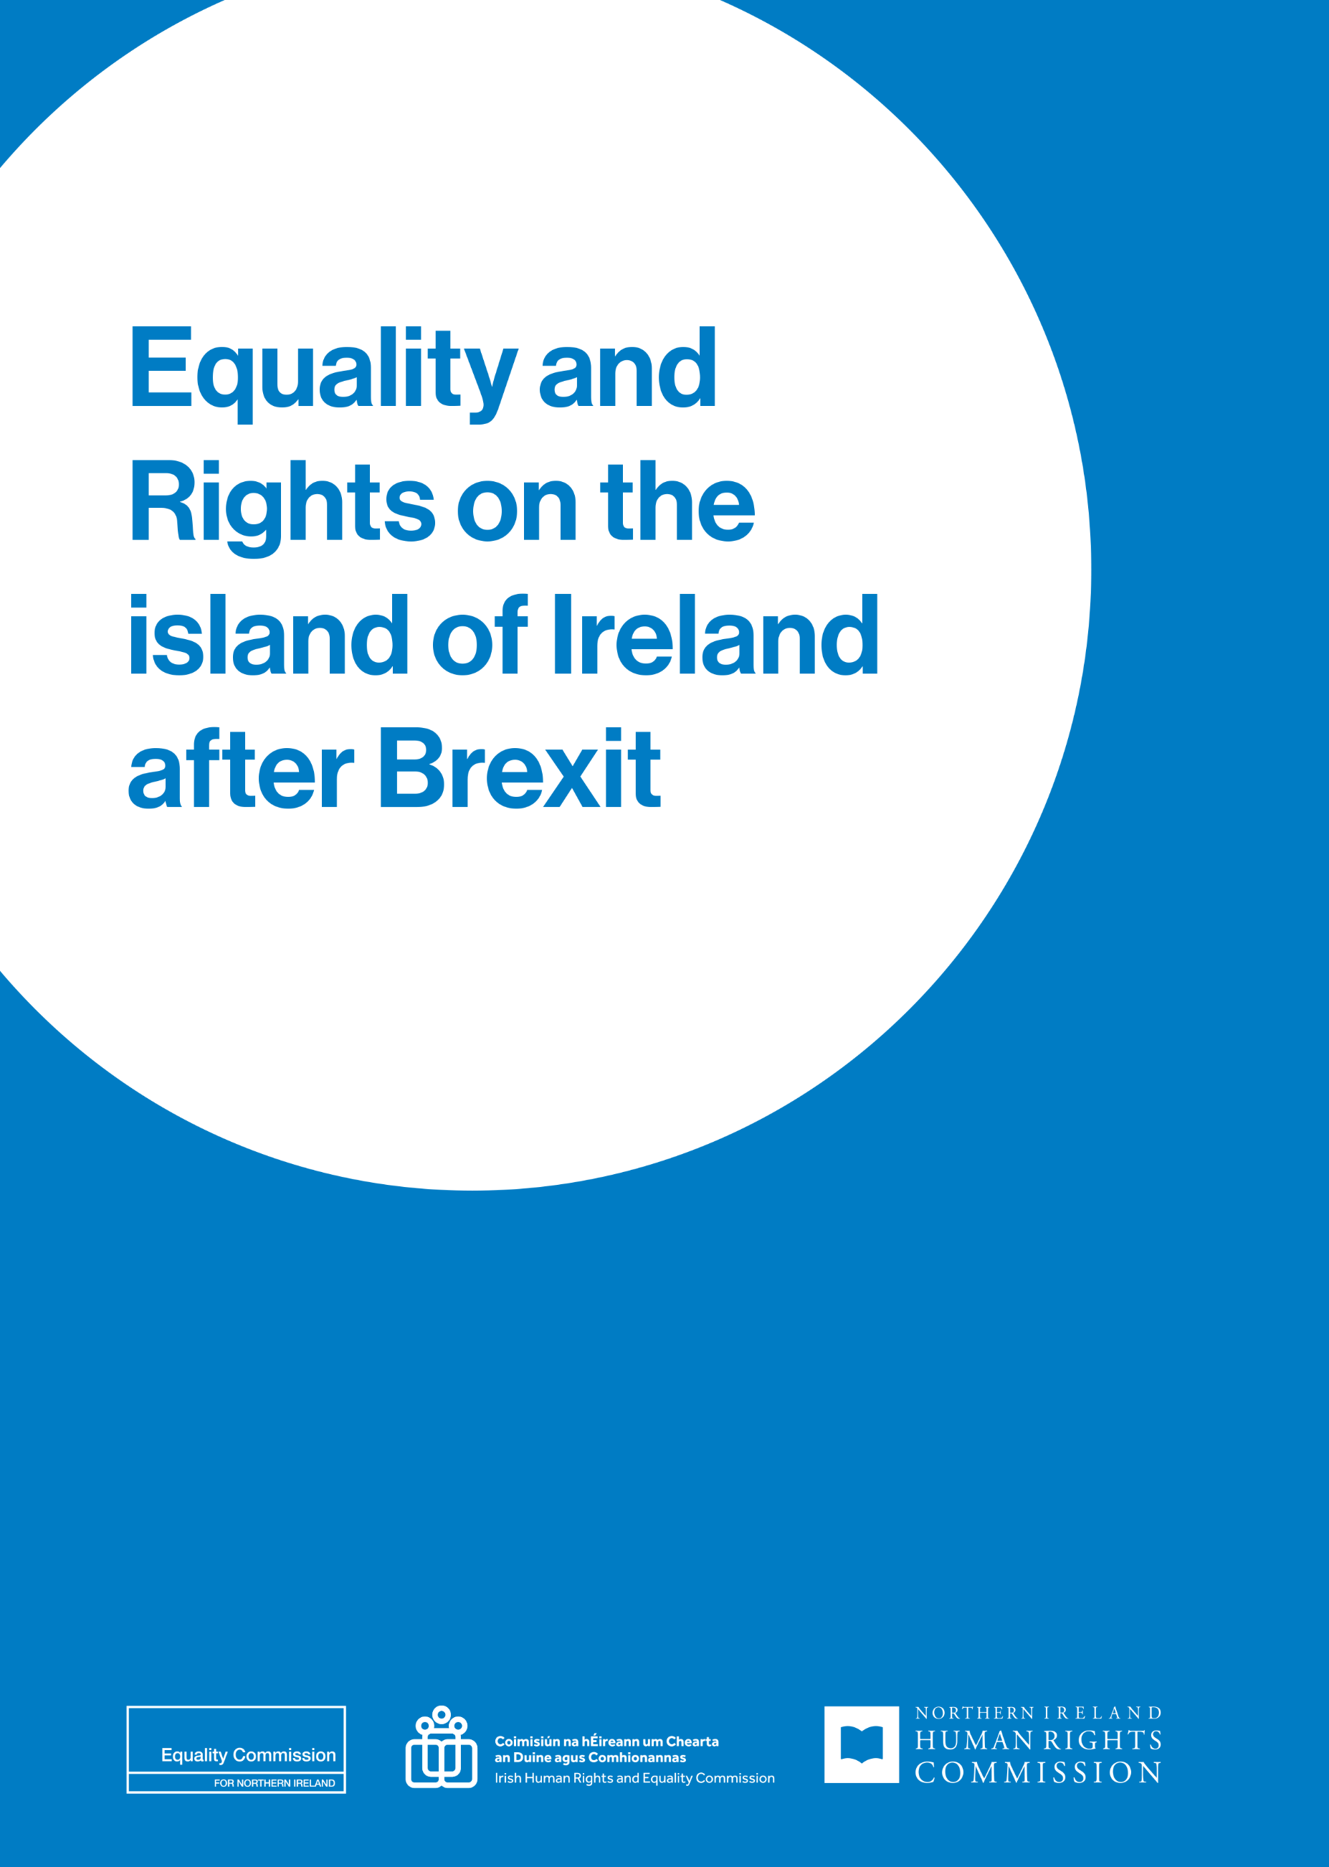

Equality and Rights on the island of Ireland after Brexit: Annual joint report of IHREC, ECNI and NIHRC on the implementation of Article 2 of the Ireland/Northern Ireland Protocol. January 2021-September 2022
Irish Human Rights and Equality Commission
Northern Ireland Human Rights Commission
Equality Commission for Northern Ireland
November 2022

Contents
Foreword 1
Overview of the Commissions 5
Report outline 6
Introduction 7
Article 2 of the Protocol on Ireland/Northern Ireland 10
Dedicated Mechanism 15
Island of Ireland dimension 16
Three Commission activity 2021 – September 2022 17
Working group meetings 17
Parliamentary engagement 19
Ministerial engagement 23
Civil society engagement 27
Research 33
Concluding comments 35
Appendix 1: About the Commissions 36

Foreword
The Belfast (Good Friday) Agreement is foundational to the rights and equality framework for the island of Ireland. It places equality and human rights protections at the heart of the peace settlement for Northern Ireland, while setting out a broad expectation of equivalence in rights protections in Ireland. Crucially, the Agreement instigated the establishment of institutions to promote and protect human rights in both jurisdictions, namely the Northern Ireland Human Rights Commission (‘NIHRC’) and one of the Irish Human Rights and Equality Commission’s (‘IHREC’) legacy bodies, the former Irish Human Rights Commission. It also specified the establishment of a Joint Committee of the two Human Rights Commissions, to serve as a forum for the consideration of rights and equality issues that affected the island of Ireland. The Belfast (Good Friday) Agreement also confirmed the intention of the Government, subject to the outcome of public consultation underway at the time, to replace the Fair Employment Commission, the Equal Opportunities Commission for NI, the Commission for Racial Equality (NI) and the Disability Council with a new statutory Equality Commission for Northern Ireland (‘ECNI’) to have responsibilities for a new statutory obligation on public authorities to pay due regard to the need to promote equality of opportunity in relation to nine equality grounds
Following the 2016 UK referendum decision to leave the European Union, our three Commissions worked within their respective remits to ensure that the human rights and equality provisions of the Belfast (Good Friday) Agreement would be protected after Brexit. The result is Article 2 of the Ireland/Northern Ireland Protocol; an important commitment by the UK Government to ensuring there is no diminution of the rights, safeguards and equality of opportunity provisions in the relevant Chapter of the Belfast (Good Friday) Agreement as a result of Brexit.
The NIHRC and ECNI have been mandated to act as a dedicated mechanism to advise on, monitor and hold the UK Government to account on the implementation of Protocol Article 2. The two Commissions exercise part of this mandate in partnership with IHREC; specifically in relation to oversight of rights and equalities issues falling within the scope of Protocol Article 2 that have an island of Ireland dimension.
As detailed in this report, our three Commissions have built a framework to govern our Protocol Article 2 work and established a joint working group to drive it. This working group has been an important way for us to consider together Protocol Article 2 issues with an island of Ireland dimension. We have also agreed that our three full Commissions will meet annually to consider the strategic direction of our joint work, utilising the expertise of our broader Commission membership. We held a fruitful first such annual meeting in November last year and are holding our second in November 2022.
Engagement with key actors to promote the effective implementation of Protocol Article 2 and understanding of our Commissions’ roles in monitoring this has been central to our work to uphold rights after Brexit. We have made regular appearances before parliamentary committees in both Dublin and Stormont. We’ve also prioritised engagement with civil society in order to connect with, and learn from, the experience of rights holders, particularly the communities on both sides of the Border whose day to day lives are hugely impacted by Brexit.
In the course of our work, the Commissions have identified where new laws risk breaching the Protocol Article 2 commitment. We have significant concerns about provisions in the Nationality and Borders Act that provide for the UK to introduce an Electronic Travel Authorisation regime. NIHRC and IHREC are concerned this could seriously undermine the Protocol commitment to avoiding a hard border and related checks and controls. Moreover, our three Commissions are concerned it could potentially lead to increased racial profiling resulting from associated checks under this regime. We are also concerned that provisions in the Nationality and Borders Act may undermine the protections for victims of trafficking provided in the EU Trafficking Directive and amount to a breach of Protocol Article 2. We have raised our concerns about these issues directly with Ireland’s Minister for Foreign Affairs, Simon Coveney TD. In addition, the ECNI and NIHRC raised these concerns with the former Secretary of State for the Home Department, The Rt Hon Priti Patel MP, and the former Secretary of State for Norther Ireland, The Rt Hon Brandon Lewis MP.
We’re also considering the risk of divergence of rights on the island more broadly, with ECNI having commissioned an expert paper on this issue on behalf of the three Commissions. Key findings from the research indicate that divergence of rights between Ireland and Northern Ireland loom in areas of European Union law relating to equality and human rights in which reform proposals are already in train. This includes the areas of work-life balance; age discrimination in access to goods, facilities and services; standards for equality bodies, and pay transparency reporting.
Given the significant and evolving risks to equality and human rights on the island of Ireland post-Brexit, the joint work of our three Commissions is more important now than ever. As this report shows, we’re working well together, as our organisations historically have done, to deal with this latest set of challenges and to support each other in discharging our mandates to promote and protect human rights and equality for everyone on the island of Ireland.
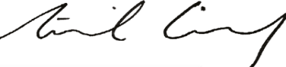
Sinéad Gibney Geraldine McGahey Alyson Kilpatrick
Chief Commissioner, Chief Commissioner, Chief Commissioner,
Irish Human Rights and Equality Commission for NI NI Human Rights Commission
Equality Commission

Overview of the Commissions
The Irish Human Rights and Equality Commission (IHREC) is Ireland’s National Human Rights Institution and its National Equality Body. It was established on 1 November 2014, as an independent public body under the Irish Human Rights and Equality Commission Act 2014. IHREC is an ‘A status’ National Human Rights Institution as accredited by the United Nations.
Both the Northern Ireland Human Rights Commission (NIHRC) and the Equality Commission for Northern Ireland (ECNI) are non-departmental public bodies established following the Belfast (Good Friday) Agreement and pursuant to the Northern Ireland Act 1998. The NIHRC is a National Human Rights Institution with ‘A status’ accreditation from the United Nations. The Equality Commission is a non-departmental public body with powers and duties that derive from the anti-discrimination legislation in Northern Ireland and the Northern Ireland Act 1998.
There is more information about the Commissions’ respective roles and remit in Appendix 1.

Report outline
This report provides an overview of the joint work of the Irish Human Rights and Equality Commission, Equality Commission for Northern Ireland, and Northern Ireland Human Rights Commission in relation to providing oversight of, and reporting on, rights and equalities issues falling within the scope of the Article 2 of the Ireland/Northern Ireland Protocol to the UK-EU Withdrawal Agreement that have an island of Ireland dimension. The report covers the period January 2021-September 2022.

Introduction
Under the terms of the 1998 Belfast (Good Friday) Agreement, it was agreed that two Human Rights Commissions would be established, the Northern Ireland Human Rights Commission (NIHRC) and one of the Irish Human Rights and Equality Commission’s (IHREC) legacy bodies, the former Irish Human Rights Commission. In addition, the Agreement confirmed the intention of Government to replace pre-existing equality bodies with the Equality Commission for Northern Ireland (ECNI).
The Agreement also provided there would be a Joint Committee of representatives of the two Human Rights Commissions as a forum for consideration of human rights issues in the island of Ireland.
Following the United Kingdom referendum decision in 2016 to leave the European Union, the Joint Committee of the Human Rights Commissions embarked on a significant programme of Brexit-related work, including research and policy work on equality and human rights issues, and an extensive programme of engagement with key officials of Ireland, Northern Ireland, the UK, the EU and the UN to ensure rights and equality issues were fully considered throughout the withdrawal process. Separate to the work of the Joint Committee, the Equality Commission for Northern Ireland also engaged significantly with a range of key officials to ensure equality rights would be protected after Brexit.
The UK left the EU on 31 January 2020 and following an initial transition period which ended on 31 December 2020, the full provisions of the Withdrawal Agreement came into operation in 2021. These include the Protocol on Ireland/Northern Ireland (‘the Protocol’), an element of the Withdrawal Agreement agreed specifically to address the unique circumstances on the island of Ireland.
The overall objectives of the Protocol are to avoid a hard border between Ireland and Northern Ireland, to protect the 1998 Belfast (Good Friday) Agreement in all its dimensions, to maintain the all island economy on the island of Ireland, and to safeguard the integrity of the EU single market.

Article 2 of the Protocol on Ireland/Northern Ireland
Article 2 of the Protocol on Ireland/Northern Ireland (‘Protocol Article 2’) concerns the rights of individuals. It states:
- The United Kingdom shall ensure that no diminution of rights, safeguards or equality of opportunity, as set out in that part of the 1998 Agreement entitled Rights, Safeguards and Equality of Opportunity results from its withdrawal from the Union, including in the area of protection against discrimination, as enshrined in the provisions of Union law listed in Annex 1 to this Protocol, and shall implement this paragraph through dedicated mechanisms.
- The United Kingdom shall continue to facilitate the related work of the institutions and bodies set up pursuant to the 1998 Agreement, including the Northern Ireland Human Rights Commission, the Equality Commission for Northern Ireland and the Joint Committee of representatives of the Human Rights Commissions of Northern Ireland and Ireland, in upholding human rights and equality standards.
With Protocol Article 2, the UK Government commits to ensuring that certain rights, safeguards and equality of opportunity protections are not diminished as a result of the UK leaving the EU. Therefore, to fall within scope of Protocol Article 2, the human right or equality protection being relied on must be covered by the relevant Chapter of the Belfast (Good Friday) Agreement and have been underpinned by EU law, including EU treaties, directives and regulations, in place on or before 31 December 2020.
In the rights, safeguards and equality of opportunity Chapter of the Belfast (Good Friday) Agreement, the parties affirmed their commitment to “the mutual respect, the civil rights and religious liberties of everyone in the community”, before affirming “in particular”:
- The right of free political thought
- The right to freedom and expression of religion
- The right to pursue democratically national and political aspirations
- The right to seek constitutional change by peaceful and legitimate means
- The right to freely chose one’s place of residence
- The right to equal opportunity in all social and economic activity regardless of class, creed, disability, gender or ethnicity
- The right to freedom from sectarian harassment
- The right of women to full and equal political participation
The UK Government has recognised other specific rights, safeguards and equality of opportunity protections in the relevant Chapter of the Agreement as forming a non-exhaustive list of rights:
- The right of victims to remember as well to contribute to a changed society
- Respect, understanding and tolerance in relation to linguistic diversity
- The need to ensure that symbols and emblems are used in a manner which promotes mutual respect rather than division.
Protocol Article 2 also commits the UK Government to ensuring there is no diminution in the area of protection against discrimination, referencing Annex 1 of the Protocol which sets out six EU equality directives:
- Gender Goods and Services Directive (Gender): Directive 2004/113/EC of 13 December 2004 implementing the principle of equal treatment between men and women in the access to and supply of goods and services;
- Recast Directive (Gender): Directive 2006/54/EC of the European Parliament and of the Council of 5 July 2006 on the implementation of the principle of equal opportunities and equal treatment of men and women in matters of employment and occupation (recast);
- Race Equality Directive (Race): Directive 2000/43/EC of 29 June 2000 implementing the principle of equal treatment between persons irrespective of racial or ethnic origin;
- Framework Employment Directive (Religion and belief; age; sexual orientation; and disability): Directive 2000/78/EC of 27 November 2000 establishing a general framework for equal treatment in employment and occupation;
- Equal Treatment Directive: Self-employment (Gender): Directive 2010/41/EU of the European Parliament and of the Council of 7 July 2010 on the application of the principle of equal treatment between men and women engaged in an activity in a self-employed capacity and repealing Council Directive 86/613/EEC;
- Equal Treatment Directive: Social security (Gender): Directive 79/7/EEC of 19 December 1978 on the progressive implementation of the principle of equal treatment for men and women in matters of social security.
The UK Government has committed not only to ensuring there is no diminution of the rights contained in the Annex 1 equality directives, but also that Northern Ireland equality law must dynamically align, or ‘keep pace’, with any enhancements made by the EU to these rights, on or after 1 January 2021.
There are other EU laws which underpin the protection of the rights and safeguards set out in the rights, safeguards, and equality of opportunity Chapter in the Belfast (Good Friday) Agreement and are therefore subject to the no diminution commitment. The UK Government has recognised these to include the Parental Leave Directive, Victims’ Directive and Pregnant Workers’ Directive, as well as specific measures aimed at protecting the rights of disabled people.
ECNI and NIHRC consider there are additional EU measures that will fall within the scope of Protocol Article 2, and are developing a working paper setting out their views on which other EU laws and obligations underpin the rights and safeguards in the relevant part of the Belfast (Good Friday) Agreement. This is due to be published before the end of 2022.
The commitment to protect these rights and safeguards is a recognition of the importance and centrality of rights and equality protections in the Belfast (Good Friday) Agreement and of the fact that this Agreement has underpinned the peace process on the island of Ireland.
The commitment is binding on the UK Government and Parliament, the Northern Ireland Executive and the Assembly as a matter of international law, and became UK domestic law on 1 January 2021 further to the EU (Withdrawal Agreement) Act 2020 passed by the UK Parliament in January 2020.

Dedicated Mechanism
Article 2(1) of the Protocol provides that the no-diminution guarantee in that paragraph will be implemented through dedicated mechanisms. In this respect, the UK Government has conferred new statutory powers and related resources on the NIHRC and ECNI, which include new functions to monitor, advise, report on, promote, and enforce the implementation of Protocol Article 2. These new powers took effect from 1 January 2021. The Commissions can carry out these powers and duties either jointly or separately.
Article 14 of the Protocol refers to a Specialised Committee created to facilitate the implementation and application of the Protocol. The Specialised Committee is mandated to consider any matter of relevance to Protocol Article 2 brought to its attention by the NIHRC, ECNI, or the Joint Committee of representatives of the Human Rights Commissions of Northern Ireland and Ireland.

Island of Ireland dimension
In addition, the NIHRC, ECNI and IHREC are working together to provide oversight of, and reporting on, rights and equalities issues falling within the scope of the Article 2 commitment that have an island of Ireland dimension.
In March 2021, the three Commissions agreed a Memorandum of Understanding that sets out working arrangements for fulfilling this mandate.
In terms of practical working arrangements, the three Commissions have established a working group to progress this work, comprising the respective Chief Commissioners, a Board member and the Chief Executives of each Commission. The working group will normally meet four times a year to consider areas for joint working, to share information about issues arising and what may need to be reported on.
In addition, there will be an annual meeting of all members of the three Commissions to review progress and issues together.
The Commissions acknowledge that, in carrying out these roles and responsibilities, this arrangement does not alter the constitutional status of the Joint Committee as set out in the Belfast (Good Friday) Agreement, which may additionally and separately pursue any other matters within its mandate.

Three Commission activity 2021 – September 2022

Working group meetings
The working group of the three Commissions met four times in 2021 and twice to date in 2022. At these meetings the Commissions considered areas for joint working, for example, in relation to North/South Civic Engagement, and shared information and updates about relevant activities, including in relation to ongoing research, advice to government, and other legal and policy work on Protocol Article 2. The working group has been an important way for the three Commissions to consider together the broader work of the Dedicated Mechanism.

Pictured from left to right. Top row: Sinéad Gibney, Chief Commissioner, IHREC; Jarlath Kearney, Commissioner, ECNI; David Russell, Chief Executive, NIHRC; Eilis Haughey, Director (Human Rights after EU Withdrawal), NIHRC. Middle row: Alyson Kilpatrick, Chief Commissioner, NIHRC. Bottom row: Laurence Bond, then Director, IHREC; Geraldine McGahey, Chief Commissioner, ECNI; Roisin Mallon, Director, Dedicated Mechanism Unit, ECNI; Evelyn Collins, Chief Executive, ECNI.

First joint board meeting of the three Commissions
The first annual meeting of all members of the three Commissions took place in Dundalk, Co. Louth on 23 November 2021.
The meeting convened the broader membership of the three Commissions to review and plan joint work in respect of Protocol Article 2. Discussions focused on the important strategic direction of the work of the Dedicated Mechanism, including around communication and stakeholder engagement.
At the meeting, the Commissions heard via video address from Minister of State for Northern Ireland, Conor Burns, MP, and Irish Minister for Foreign Affairs, Simon Coveney, TD. Both Ministers referred to their respective Governments’ respect for upholding the Article 2 commitment on equality and human rights and supporting the work of the three Commissions in this.

Pictured left to right are: Sinéad Gibney, Chief Commissioner (IHREC), Laurence Bond, Director (IHREC), Geraldine McGahey, Chief Commissioner (ECNI), Evelyn Collins, Chief Executive (ECNI), David Russell, Chief Executive (NIHRC) and Alyson Kilpatrick, Chief Commissioner (NIHRC)

Parliamentary engagement

Northern Ireland Assembly Committee for the Executive Office
The Commissions engaged with the Northern Ireland Assembly Committee for the Executive Office twice in 2021, in April and December. This built on prior appearances before the Committee in relation to Protocol Article 2 in 2020.
On 14 April 2021, the Commissions – ECNI and NIHRC represented by their Chief Commissioners and IHREC by Commission member Michael Finucane – briefed the Committee on ongoing activities related to their Protocol Article 2 mandates and the oversight arrangements put in place by the Commissions in respect of Protocol Article 2 issues with an island of Ireland dimension. Amongst the matters discussed was the need for the UK Government and the EU to reach a solution that minimises checks on assistance dogs travelling between Great Britain and Northern Ireland.
On 15 December 2021, the Chief Commissioners of the three Commissions updated the Committee on joint work to ensure the protection of equality and human rights following Brexit, including civil society engagement and work in relation to provisions in the UK Nationality and Borders Bill. In the course of the discussion, the Chief Commissioners of NIHRC and ECNI outlined, and sought the Committee’s support for, their recommendation that explanatory memoranda attached to relevant NI or UK-wide legislative measures make clear what consideration has been given to ensuring conformity with the Protocol Article 2 commitment.

Seanad Special Select Committee on the Withdrawal of the UK from the EU
On 24 May 2021, the Chief Commissioners of the three Commissions appeared before the Seanad Special Select Committee on the Withdrawal of the UK from the EU. The Chief Commissioners briefed the Committee on the three Commissions’ role and responsibilities post-Brexit, including in relation to island of Ireland oversight arrangements. The discussion covered a range of issues including citizenship rights, participation in public life, the legal underpinnings of the Common Travel Area, information and awareness raising for Border and rural communities, and the potential for racial profiling to occur at the Border.
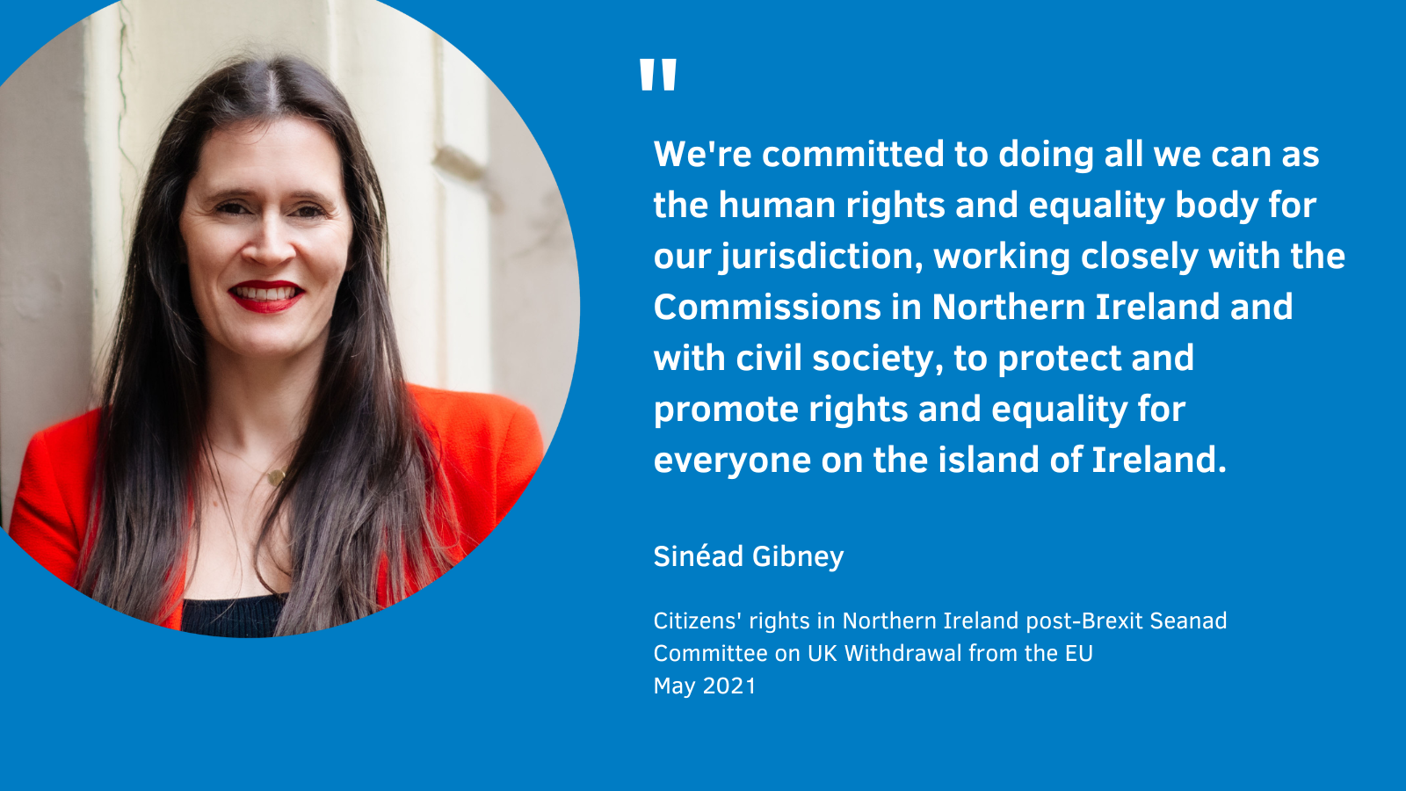

Joint Oireachtas Committee on the Implementation of the Good Friday Agreement
On 22 September 2022, the Chief Commissioners of the three Commissions appeared before the Joint Oireachtas Committee on the Implementation of the Good Friday Agreement. The Chief Commissioners outlined to the Committee concerns regarding human rights and equality issues in Northern Ireland post-Brexit, noting in particular the adverse equality and rights impacts that may result from the introduction of Electronic Travel Authorisations under the UK Government’s Nationality and Borders Act 2022.
The Chief Commissioners engaged with the Committee members in relation to a range of issues, including the importance of long-term North-South equivalence of rights, concerns about the potential for increased racial profiling at the Border, the UK Government’s proposed Northern Ireland (Legacy and Reconciliation) Bill, and the role and relevance of the European Convention on Human Rights in interpreting the Belfast (Good Friday) Agreement and the Protocol. The Committee members highlighted the importance of the meeting and noted their willingness to engage further with the three Commissions.
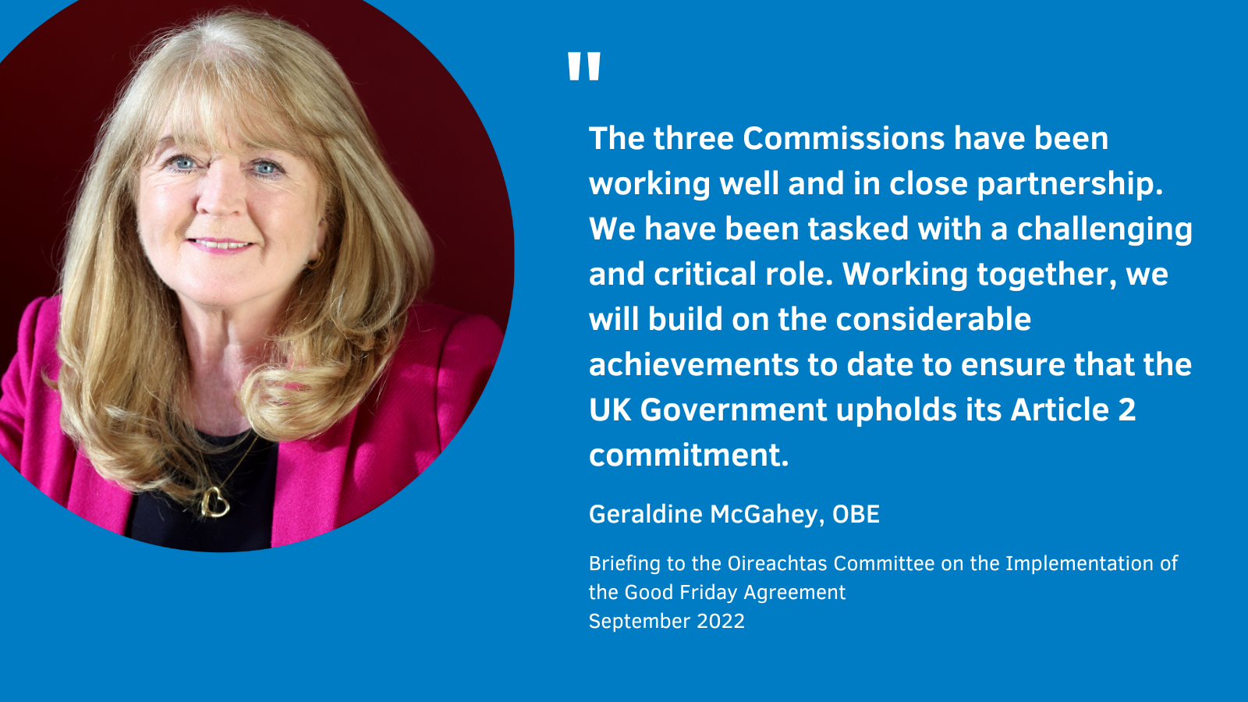

Ministerial engagement

Correspondence with Minister Coveney and Minister of State Burns
In December 2021, the three Commissions wrote to both Irish Minister for Foreign Affairs, Simon Coveney TD, and Minister of State for Northern Ireland, Conor Burns MP, to thank them for their participation in the first annual joint board meeting of the three Commissions in November 2021.
With the correspondence, the Commissions welcomed both the Irish and UK Government’s recognition of the vital importance of the Article 2 commitment and the significance of the three Commissions’ effective cooperation and collaboration in this respect to date. The Commissions also highlighted to both Ministers the barriers experienced by equality groups in terms of accessing goods or travelling between Great Britain and Northern Ireland. This has included, for example, issues relating to the movement of assistance dogs between Great Britain and Northern Ireland; access to some kosher and halal food and ritual items by the Jewish and Muslim communities in Northern Ireland; and access to medicines.
The Commissions recommended to both Ministers:
- That there be no changes to the Protocol that would result in a weakening of either the Article 2 commitment or its related oversight mechanisms.
- That the UK Government and EU urgently reach agreement on long-term, sustainable solutions to issues concerning access to goods or travel between Great Britain and Northern Ireland, with a view to limiting the impact on affected groups including people with disabilities and people from minority ethnic groups.
Responding to the Commissions, Minister Coveney reiterated the Protocol Article 2 commitment to no diminution of rights, safeguards and equality of opportunity is essential, and acknowledged the role of the Dedicated Mechanism in ensuring the special circumstances of the island of Ireland are recognised and protected as the EU-UK relationship evolves post Brexit. Minister Coveney also outlined the European Commission’s actions towards addressing the specific issues raised by the Commissions relating to the movement of assistance dogs and access to certain food products and medicines in Northern Ireland.

Correspondence with Minister Coveney regarding the UK Nationality and Borders Bill
The Commissions wrote jointly to Minister Coveney on 4 March 2022 to raise concerns about provisions under the UK Nationality and Borders Bill in relation to human trafficking and Electronic Travel Authorisation, potentially contributing to a divergence of rights on the Island of Ireland.
Outlining how the EU Trafficking Directive should also fall within the scope of the Protocol Article 2 commitment, the Commissions noted their concern at the lack of evidence as to what, if any, consideration had been given to Protocol Article 2 obligations in the development of provisions in the Bill concerning the rights of victims of human trafficking, which the Commissions warned may not be compliant with Article 2. The Commissions noted further concern that the Bill’s proposed disapplication of the Trafficking Directive in Northern Ireland, while Ireland remains bound by it, may lead to a divergence of rights in relation to victims of human trafficking on the island of Ireland.
The Commissions also raised with the Minister concerns about the Bill’s proposed introduction of an Electronic Travel Authorisation (‘ETA’) regime. ETAs would essentially require those wishing to travel to the UK – bar British and Irish Citizens – to seek permission in advance of travel. This would affect a significant number of individuals who do not hold a recognised UK immigration status, despite unrestricted travel being available to them on the island of Ireland under the current system. British and Irish citizens may feel the need to start carrying passports when crossing the Border, even if not required to go through immigration control.
The Commissions raised with Minister Coveney particular concern at the potential for racial profiling resulting from associated checks. Moreover, the Commissions noted that in order to protect the Belfast (Good Friday) Agreement, the UK Government committed under the Protocol to avoiding a hard border “including…related checks and controls”, and gave undertakings in respect of protecting North-South co-operation and the Common Travel Area. All of these contribute to the enjoyment of private and family life, particularly for those who cross the Border to shop, access services or visit family.
The Commissions recommended to the Minister:
- That certain provisions in the UK Nationality and Borders Bill be amended to exclude Northern Ireland in order to ensure no diminution of the rights of victims of trafficking in Northern Ireland and to avoid a potential breach of Article 2.
- That all journeys into Northern Ireland, that originate from Ireland, should be exempt from ETA requirements.

Civil society engagement
The Commissions have proactively engaged with civil society in relation to Protocol Article 2, with a view to raising awareness of the Article 2 commitment and the related roles of the Commissions and hearing directly the lived experiences of the impact of Brexit to date.

Shared Island Dialogue Series: ‘Equality on a Shared Island’
The three Commissions participated in the fourth dialogue session of the Irish Government’s Shared Island Dialogue series in May 2021. The series is part of the Government’s Shared Island Initiative, which aims to foster constructive and inclusive civic dialogue on all aspects of a shared future on the island underpinned by the Good Friday Agreement.
The dialogue session saw the Commissions’ three Chief Commissioners take part in a panel discussion that considered the current progress of the equality and rights agenda on the island, joint challenges being faced both north and south in this regard, and possible deeper cooperation to advance equality on the island. The discussion covered a wide range of issues including the achievements on rights and equality issues since the Belfast (Good Friday) Agreement, the value of equivalence of rights on the island, forms and experiences of inequality on both sides of the Border, and the importance of ensuring non-diminution of rights in Northern Ireland post-Brexit. More than 100 equality and inclusivity activists, campaigners and representative groups from across communities and traditions on the island took part in the event.

‘Rights After Brexit’ event with the Centre for Cross Border Studies, May 2021
In May 2021, the three Commission’s held a ‘Rights After Brexit’ event in partnership with the Centre for Cross Border Studies.
The event saw the Commissions outline the new roles and responsibilities for each organisation post-Brexit, including joint work on island of Ireland oversight arrangements, and discuss the impact of Brexit with representatives of 26 cross-Border civil society and local community groups.
The Commissions heard from these groups about the issues and concerns affecting their Border communities. These included concerns about women’s rights, the rights of Roma and Traveller communities, cross-Border healthcare, the need for the rural-proofing and Border-proofing of policies by governments and agencies, and the potential impact of the loss of EU funding on rural and cross-Border communities.
The Commissions collected feedback after the event via a survey of event participants, with the results indicating that the event was received positively overall and that it promoted better understandings of Protocol Article 2, the role and remit of the Dedicated Mechanism, and of the three Commissions’ island of Ireland scrutiny work.
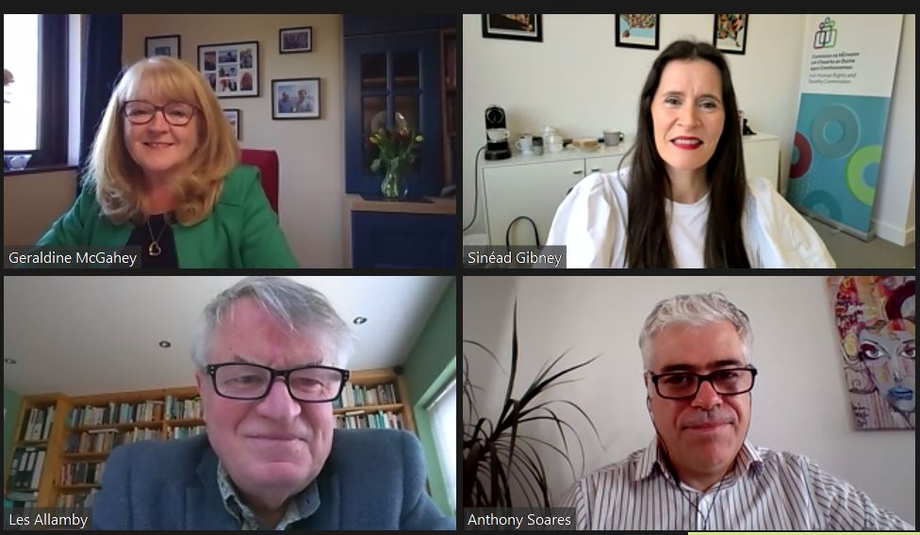
Pictured are: Geraldine McGahey, Chief Commissioner, ECNI (top left); Sinéad Gibney, Chief Commissioner, IHREC (top right); Les Allamby, then Chief Commissioner, NIHRC (bottom left); and Dr. Anthony Soares, Director, Centre for Cross Border Studies (bottom right).

Human Rights Centre in the School of Law at Queen's University Belfast
On 26 October 2021, the Commissions’ three Chief Commissioners addressed the Human Rights Centre in the School of Law at Queen's University Belfast about the Commissions’ joint work to protect rights with an island of Ireland dimension post-Brexit.

Pictured: Alyson Kilpatrick, Chief Commissioner, NIHRC (top left); Sinéad Gibney, Chief Commissioner, IHREC (top right), Professor Colin Harvey, Queen's University Belfast (bottom left); Geraldine McGahey, Chief Commissioner, ECNI (bottom right).

Engagement with Equality Coalition Northern Ireland, February 2022
On 1 February 2022, the Commissions met with representatives of the Equality Coalition of Northern Ireland. The Commissions updated the Coalition on ongoing and planned activities in relation to the Protocol Article 2 commitment and heard from its representatives about priority issues of concern in relation to equality and rights after Brexit. The issues discussed included the scope of Protocol Article 2, potential breaches of the Protocol Article 2 commitment, and UK Government’s proposals for reform of the UK Human Rights Act 1998.
The Commissions followed up on this meeting by issuing joint correspondence from the Chief Commissioners to the Coalition. This provided detailed updates on policy, research, legal and engagement activities undertaken by the Commissions in relation to the Protocol Article 2 commitment. The Commissions acknowledged the vital importance of continued and close engagement with the Coalition as a means of informing and strengthening their work as the Dedicated Mechanism.

‘Rights after Brexit: Minority ethnic groups, migrant people and border communities’, March 2022
On 14 March 2022, the Commissions held an event in City of Derry to consider cross-Border equality and human rights after Brexit with a focus on minority ethnic groups, migrant people and border communities in the North West region.
The event saw over 70 people from across a diverse range of sectors convene with the Commissions, with ECNI and NIHRC represented by their respective Chief Commissioners, Geraldine McGahey and Alyson Kilpatrick, and IHREC represented by Commission member Michael Finucane.
Also speaking at the event were Lilian Seenoi-Barr, Director of Programmes at the North West Migrants Forum, and Kendall Bousquet, Advocacy Officer for the Migrant Centre NI, who highlighted the concerns being expressed by local minority ethnic and migrant communities.
Attendees, who were able to participate in person or online, had the opportunity to raise issues and share experiences during a question and answer session and open forum during the event. A wide range of issues were raised including concerns relating to access to cross-Border services such as healthcare, education and work and increased racial profiling in terms of cross-border travel as a result of Brexit..
In a post-event feedback survey, over 90% of participants rated the event as ‘good’ or ‘very good’ and agreed that the event covered the key issues in this area. Almost all participants indicated that after the event they had a better understanding of the UK Government’s Article 2 commitment, the role and remit of the three Commissions, and the issues relating to cross-Border equality and human rights after Brexit faced by minority groups, migrant people, and border communities in the North West.
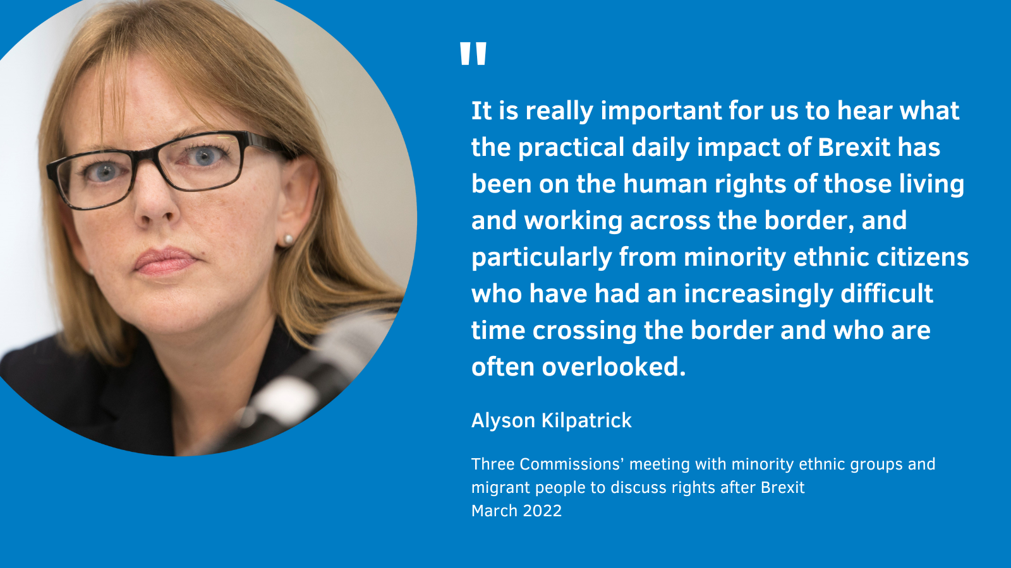

Research

European Union Developments in Equality and Human Rights: The Impact of Brexit on the Divergence of Rights and Best Practice on the Island of Ireland
On behalf of the three Commissions, the Equality Commission for Northern Ireland contracted a team of expert researchers to report on European Union developments in Equality and Human Rights: The Impact of Brexit on the divergence of rights and best practice on the island of Ireland.
The research maps rights and equality provisions in Northern Ireland after Brexit, and assesses the equivalence and divergence in rights and equality protections in Ireland and Northern Ireland. It sets out the Protocol Article 2 commitment and corresponding oversight arrangements, exploring the broader implications of Article 2 for equality and human rights protections in Northern Ireland. The report also outlines the implications of the obligation for legislation in Northern Ireland to maintain dynamic alignment with the EU equality laws listed in Protocol Annex 1, as well tracking developments in EU policy and law that will be relevant to the Article 2 obligation.
Overall, the expert paper analyses the impact, and/or potential impact, of Brexit as regards divergence of equality and human rights protections and EU best practice on the island of Ireland in relation to EU law, case law of the Court of Justice of the European Union, and EU best practice. Its key findings include the following.
- While EU membership facilitated broad alignment of equality and human rights law across the island of Ireland, and also between Northern Ireland and Great Britain, some significant areas of divergence existed prior to Brexit. These did not pose immediate legal issues prior to Brexit, but in the post-Brexit context, North-South divergences raise potential issues in terms of Article 2’s non-diminution commitment, which gives legal significance to some terms of the 1998 Agreement which would previously have been regarded as aspirations.
- Further divergences between Ireland and Northern Ireland loom in areas of European Union law relating to equality and human rights in which reform proposals are already in train, including in the areas of work-life balance; age discrimination in access to goods, facilities and services; and pay transparency reporting.
The expert report was finalised in July 2022. The Commissions will be publishing it in January 2023 and taking forward policy recommendations informed by the research in due course.

Concluding comments
As this joint report shows, the three Commissions are working in close and effective partnership to protect equality and human rights on the island of Ireland after Brexit. We have built a framework for cooperation between our three organisations, with the agreement of our shared Memorandum of Understanding and the establishment of our Protocol Article 2 working group. Working within that framework, we have raised awareness and understanding of Protocol Article 2, and the Commissions’ roles in monitoring this, amongst key stakeholders in Parliament and across civil society on both sides of the border. Moreover, we have identified where there are serious risks of a breach of Article 2, for example in relation to the proposed introduction of Electronic Travel Authorisations and recommended to Government the policy responses that could be taken to address these risks. Going forward, the Commissions are fully committed to continuing and developing these strands of joint working, to ensure we are effective in discharging our mandates to protect human rights and equality after Brexit for everyone on the island of Ireland.

Appendix 1: About the Commissions
The NIHRC and the ECNI are mandated in accordance with Article 2(1) of the Protocol on Ireland/Northern Ireland of the UK-EU Withdrawal Agreement to oversee the UK Government’s commitment on rights and equality in Northern Ireland after EU withdrawal.
The Commissions’ functions for this purpose, set out in Sections 78A-78E of the Northern Ireland Act 1998, are:
- monitoring the implementation of Protocol Article 2 (rights of individuals);
- reporting to the Secretary of State for NI and the NI Executive Office on the implementation of Protocol Article 2;
- advising the Secretary of State for NI and the NI Executive of legislative and other measures which ought to be taken to implement Protocol Article 2;
- advising the NI Assembly (or a committee of the Assembly) whether a Bill is compatible with Protocol Article 2;
- promoting understanding and awareness of the importance of Protocol Article 2, including undertaking, commissioning or providing financial or other assistance for research and educational activities;
- bringing any appropriate matters of relevance to Protocol Article 2 to the attention of the Specialised Committee on the Protocol;
- taking judicial review proceedings in respect of an alleged breach (or potential future breach) of Protocol Article 2;
- assisting persons in legal proceedings or proposed proceedings in respect of an alleged breach (or potential future breach) of Protocol Article 2; and
- intervening in legal proceedings in so far as they relate to an alleged breach (or potential future breach) of Protocol Article 2.
In addition, the NIHRC, ECNI and IHREC will work together to provide oversight of, and report on, issues which engage Protocol Article 2 that have an island of Ireland dimension.

NIHRC
The Northern Ireland Human Rights Commission (NIHRC) was established as a result of the Belfast (Good Friday) Agreement 1998. The NIHRC’s governing legislation is the Northern Ireland Act 1998, as amended by the Justice and Security (Northern Ireland) Act 2007 and the European Union (Withdrawal Agreement) Act 2020.
The NIHRC is a National Human Rights Institution with A status accreditation from the United Nations. This recognition means that the organisation operates independently in full accordance with the UN General Assembly Resolution 48/134 (the Paris Principles) reporting to UN treaty bodies and exercising speaking rights before the UN Human Rights Council.
The Commission is also a non-departmental public body and receives grant-in-aid from the UK Government through the NI Office. We report to Parliament through the Secretary of State for NI.
The NIHRC also has additional functions, as set out in the Northern Ireland Act 1998, to:
- keep under review the adequacy and effectiveness in NI of law and practice relating to the protection of human rights;
- advise the Secretary of State for NI and the Executive Committee of the NI Assembly of legislative and other measures which ought to be taken to protect human rights;
- advise the NI Assembly whether proposed legislation is compatible with human rights standards;
- promote understanding and awareness of the importance of human rights in NI, for example, by undertaking or commissioning or otherwise assisting research and educational activities;
- give assistance to individuals who apply to it for help in relation to proceedings involving law or practice concerning the protection of human rights;
- bring proceedings involving law or practice concerning the protection of human rights;
- intervene in legal proceedings concerning human rights where it need not be a victim or potential victim of the unlawful act to which the proceedings relate;
- conduct investigations;
- require a person to provide information and documents in their possession, and to give oral evidence, in respect of an investigation;
- enter a specified place of detention in NI, in respect of an investigation; and
- publish its advice and the outcome of its research and investigations.

ECNI
The Equality Commission for Northern Ireland (ECNI) is an executive non-departmental public body sponsored by the Executive Office (TEO). The ECNI, established on 1 October 1999 under the Northern Ireland Act 1998, assumed, along with the responsibilities for statutory equality duties and new disability matters, the duties and responsibilities of four former organisations:
- The Commission for Racial Equality for Northern Ireland;
- The Equal Opportunities Commission for Northern Ireland;
- The Fair Employment Commission for Northern Ireland; and
- The Northern Ireland Disability Council.
Since October 1999, additional duties and responsibilities with respect to age, disability, sexual orientation and special educational needs have also been assumed.
During 2009, jointly with the NIHRC, the ECNI was designated as the independent mechanism for NI of the UN Convention on the Rights of Persons with Disabilities (UNCRPD) with the role of promoting, protecting and monitoring the implementation of the Convention.
The main pieces of legislation from which the Commission derives its duties and powers are:
- Sex Discrimination (NI) Order 1976, as amended;
- Disability Discrimination Act 1995, as amended;
- Race Relations (NI) Order 1997, as amended;
- Fair Employment and Treatment (NI) Order 1998, as amended;
- Northern Ireland Act 1998, as amended;
- Equality (Disability, etc.) (NI) Order 2000;
- Employment Equality (Sexual Orientation) Regulations (NI) 2003, as amended;
- Special Educational Needs and Disability (NI) Order 2005, as amended;
- Disability Discrimination (NI) Order 2006;
- Employment Equality (Age) Regulations (NI) 2006, as amended; and
- Equality Act (Sexual Orientation) Regulations (NI) 2006, as amended.

IHREC
The Irish Human Rights and Equality Commission (IHREC) was established on 1 November 2014, as an independent public body under the Irish Human Rights and Equality Commission Act 2014. IHREC is Ireland’s independent National Human Rights Institution and its National Equality Body. Since 2020 it is also Ireland’s Independent National Rapporteur on the Trafficking of Human Beings.
IHREC Members are appointed by President Michael D. Higgins, following a resolution by both Houses of the Oireachtas. IHREC operates independently of Government, with its institutional independence guaranteed in its establishing legislation, which provides for accountability of the Commission for its statutory functions to the Oireachtas.
The overall statutory functions of IHREC provided for in section 10 of the legislation are:
- to protect and promote human rights and equality;
- to encourage the development of a culture of respect for human rights, equality, and intercultural understanding in the State;
- to promote understanding and awareness of the importance of human rights and equality in the State;
- to encourage good practice in intercultural relations, to promote tolerance and acceptance of diversity in the State and respect for the freedom and dignity of each person; and
- to work towards the elimination of human rights abuses, discrimination and prohibited conduct.
In undertaking its mandate, IHREC is explicitly tasked with contributing to the development of a society in which:
- there is respect for, and protection of, each person’s human rights;
- there is respect for the dignity and worth of each person;
- a person’s ability to achieve his or her potential is not limited by prejudice, discrimination, neglect or prohibited conduct;
- each person has a fair and equal opportunity to participate in the economic, political, social or cultural life of the State; and
- there is mutual respect between persons, including classes of persons, based on a shared understanding of the value of diversity within society and on a shared respect for equality and human rights.

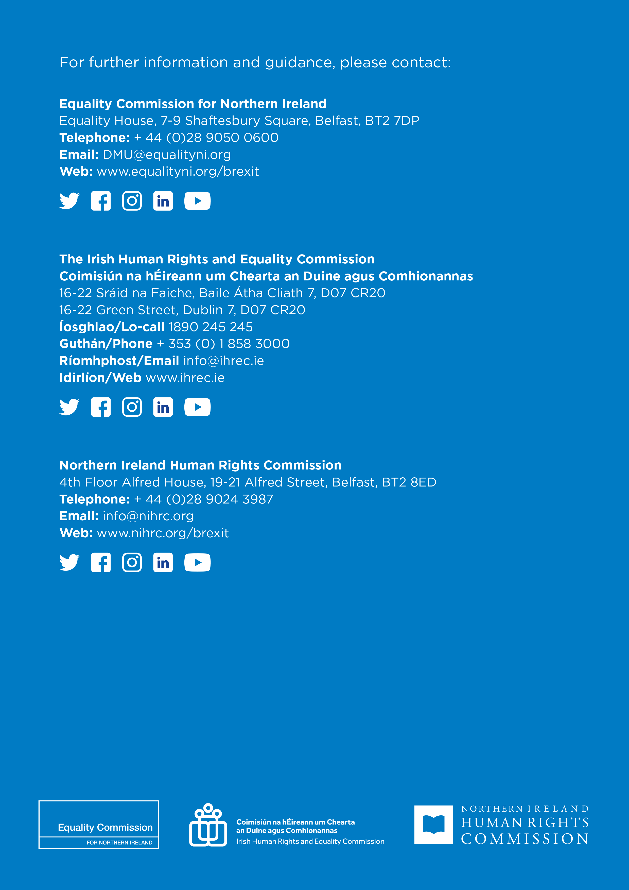

Publications included: Joint Committee of the Irish Human Rights and Equality Commission and the Northern Ireland Human Rights Commission, Policy statement on the United Kingdom withdrawal from the European Union, March 2018. Colin Murray, Aoife O’Donoghue and Ben Warwick, Discussion paper on Brexit, January 2018; Sylvia de Mars, Colin Murray, Aoife O’Donoghue and Ben Warwick, Discussion Paper on the Common Travel Area, November 2018; Amanda Kramer, Rachael Dickson, Anni Pues, Evolving Justice Arrangements Post-Brexit, August 2019; Alison Harvey, A Legal Analysis of Incorporating Into UK Law the Birthright Commitment under the Belfast (Good Friday) Agreement 1998, March 2020; Sylvia de Mars, Colin Murray, Aoife O’Donoghue & Ben Warwick, Continuing EU Citizenship “Rights, Opportunities and Benefits” in Northern Ireland after Brexit, March 2020.
This included engagement with: Simon Coveney TD, Tánaiste and Minister for Foreign Affairs and Trade with responsibility for Brexit; key officials in the permanent missions of both Ireland and the UK to the UN; Michel Barnier, the EU Commission’s Chief Brexit Negotiator and his team; the Parliamentary Under Secretary of State for Northern Ireland, Lord Duncan; the UK Permanent Representative to the EU, Sir Tim Barrow; Declan Kelleher, the Irish Permanent Representative to the EU and his officials; and Sir Robin Walker MP, the Parliamentary Under Secretary of State at the Department for Exiting the European Union; the Oireachtas JointCommittee on Justice and Equality; UN High Commissioner for Human Rights Michelle Bachelet. See: IHREC, Annual Report 2017, at p.28; Annual Report 2018, at p.34-36; Annual Report 2019, at p.46; Annual Report 2020, at p.38.
This included engagement with UK Government Ministers, and senior European Commission officials.
Agreement on the withdrawal of the United Kingdom of Great Britain and Northern Ireland from the European Union and the European Atomic Energy Community.
Protocol on Ireland/Northern Ireland.
In one recital to the Protocol, the EU and the UK recall ‘the commitment of the United Kingdom to protect North-South cooperation and its guarantee of avoiding a hard border, including any physical infrastructure or related checks and controls’.
In one of the recitals to the Protocol, the EU and the UK affirm ‘that the Good Friday or Belfast Agreement of 10 April 1998 between the Government of the United Kingdom, the Government of Ireland and the other participants in the multi-party negotiations (the "1998 Agreement"), which is annexed to the British-Irish Agreement of the same date (the "British-Irish Agreement"), including its subsequent implementation agreements and arrangements, should be protected in all its parts’.
In a recital to the Protocol, the EU and UK underline ‘their firm commitment to no customs and regulatory checks or controls and related physical infrastructure at the border between Ireland and Northern Ireland’.
One of the recitals to the Protocol notes that the EU and UK are ‘mindful that the rights and obligations of Ireland under the rules of the Union's internal market and customs union must be fully respected’.
Article 13 (3), Ireland/Northern Ireland Protocol to the UK-EU Withdrawal Agreement.
Northern Ireland Office, ‘UK Government Commitment to “No Diminution of Rights, Safeguards and Equality of Opportunity” in Northern Ireland: What does it Mean and How will it be Implemented?’ (NIO, 2020), at para 13.
Measures identified to date include additional protections for victims and employment protections for workers. Further, ECNI and NIHRC are of the view that there is the potential for additional underpinning EU law to fall within the scope of Protocol Article 2, including in relation to: the general commitment to the “civil rights and religious liberties of everyone in the community” in the relevant part of the Belfast (Good Friday) Agreement; the UK Government commitment in that chapter to incorporate the ECHR into domestic law; the requirement in the Rights, Safeguards and Equality of Opportunity chapter for advice on a Bill of Rights to draw on ‘international instruments and experience’; and CJEU rulings relevant to the interpretation of the EU laws referenced in Annex 1 of the Protocol. See Annual Report of the NIHRC and the ECNI on the implementation of Protocol Article 2 2021 – 2022, July 2022, at p.115-117.
Working Paper on the Scope of Article 2(1) of the Ireland/ Northern Ireland Protocol to the UK-EU Withdrawal Agreement (ECNI and NIHRC, forthcoming).
The Protocol on Ireland/Northern Ireland automatically entered into force at 11pm on 31 December 2020 at the end of the Brexit transition period, as provided for in Article 126 of the EU-UK Withdrawal Agreement.
UK Government commitment to “no diminution of rights, safeguards and equality of opportunity” in Northern Ireland: What does it mean and how will it be implemented?, at para.5.
These new statutory powers for the two Commissions were provided for by way of amendment to the Northern Ireland Act 1998 set out in Schedule 3, European Union (Withdrawal Agreement) Act 2020.
Sections 78A-78E, Northern Ireland Act 1998.
The Specialised Committee is co-chaired by the UK and EU and can draw up draft decisions and recommendations and refer them for adoption by the UK-EU Withdrawal Agreement Joint Committee. The UK-EU Withdrawal Agreement Joint Committee is responsible for the implementation and application of the UK-EU Withdrawal Agreement and is co-chaired by the UK and EU. It is empowered to make decisions in respect of the Withdrawal Agreement which are binding on the EU and UK and have the same legal effect as the Withdrawal Agreement
Article 14(c), Ireland/Northern Ireland Protocol to the UK-EU Withdrawal Agreement.
UK Government commitment to “no diminution of rights, safeguards and equality of opportunity” in Northern Ireland: What does it mean and how will it be implemented?, para.19.
Equality Commission for Northern Ireland, Irish Human Rights and Equality Commission, and Northern Ireland Human Rights Commission, Ireland/Northern Ireland Protocol of the European Union (EU) Withdrawal Agreement, Article 2: island of Ireland dimension. Memorandum of Understanding. March 2021.
The UK Government has affirmed that this arrangement does not alter the constitutional status of the Joint Committee of the two Human Rights Commissions, and that this work of the Joint Committee is consistent with its core functions as set out in the Belfast (Good Friday) Agreement. See UK Government commitment to “no diminution of rights, safeguards and equality of opportunity” in Northern Ireland: What does it mean and how will it be implemented?, para.19.
The Chief Commissioners of the three Commissions briefed the Committee on Protocol Article 2 on 16 December 2020. The Chief Commissioners of IHREC and NIHRC gave evidence on Protocol Article 2 to the committee on behalf of the Joint Committee of IHREC and NIHRC on 14 October 2020.
A video recording of the meeting is available here: Committee for the Executive Office Meeting Wednesday 14 April 2021. See also: the Commissions’ joint press statement in respect of the appearance, Commissions Update NI Assembly Committee for the Executive Office on Equality and Human Rights Protections post Brexit, 14 April 2021; IHREC Commission member Michael Finucane’s opening statement to the NI Assembly Executive Office Committee, 14 April 2021.
For more information about this issue, see Annual Report of the NIHRC and the ECNI on the implementation of Protocol Article 2 2021 – 2022, July 2022, at p.42-43.
A video recording of the meeting is available here: Committee for the Executive Office Meeting Wednesday 15 December 2021.https://niassembly.tv/committee-for-the-executive-office-meeting-wednesday-15-december-2021/
For more information about this issue, see Annual Report of the NIHRC and the ECNI on the implementation of Protocol Article 2 2021 – 2022, July 2022, at p.15-16.
A transcript of the meeting is available at: Seanad Special Committee on the Withdrawal of the United Kingdom from the European Union, Monday, 24 May 2021.
A transcript of the meeting is available here: Joint Committee on the Implementation of the Good Friday Agreement, 22 September 2022. See also a joint statement issued by the Commissions in respect of the appearance: Human Rights and Equality Commissions advise Oireachtas on post-Brexit protections, 22 September 2022.
The UK Government has accepted that the no-diminution commitment of the Protocol includes, but is not limited to, the Victims’ Directive. Because the Trafficking Directive protects a subsect of ‘victims’ in Northern Ireland, which are also explicitly protected under the Victims’ Directive, it should fall within the scope of Article 2. Given that human trafficking is a North-South issue with cross-border cooperation, any diminution of rights in relation to victims of human trafficking in Northern Ireland could lead to a divergence of rights on the Island of Ireland.
This follows prior correspondence from IHREC to Minister Convey on 31 January 2022 in relation to the Bill, in which IHREC emphasised in particular concerns about racial profiling at the border.
One of the recitals to the Protocol recalls ‘the commitment of the United Kingdom to protect North-South cooperation and its guarantee of avoiding a hard border, including any physical infrastructure or related checks and controls’.
As mentioned in the Foreword, the ECNI and NIHRC raised their concerns in relation to the Nationality and Borders Bill with the former Secretary of State for the Home Department, The Rt Hon Priti Patel MP, and the former Secretary of State for Norther Ireland, The Rt Hon Brandon Lewis MP in February 2022.
See also Joint NIHRC / ECNI Briefing Paper on the Modern Slavery and Human Trafficking and Electronic Travel Authorisation provisions in the Nationality and Borders Bill, 27 January 2022.
This recommendation was made specifically by NIHRC and IHREC but not ECNI, in line with the respective statutory remits of the three Commissions.
A report on the dialogue session is available to download from the Department of the Taoiseach, Shared Island Dialogues [webpage].
Post-event commentary from Commission representatives and other event participants is available in video format on the ECNI Youtube channel: Rights After Brexit – North West Event, 14 March 2022.
The research team comprised the following academics: Sarah Craig, Anurag Deb, Eleni Frantziou, Alexander Horne, Colin Murray, Clare Rice and Jane Rooney.

