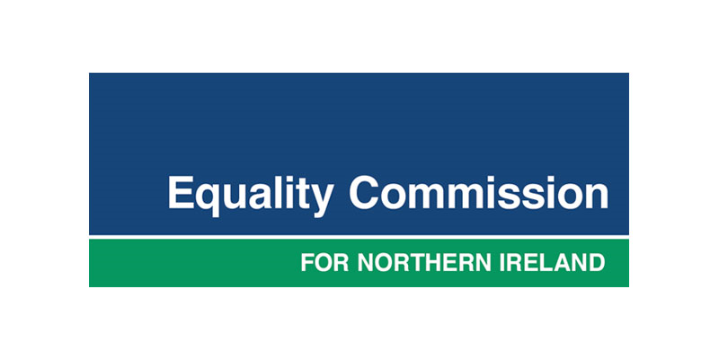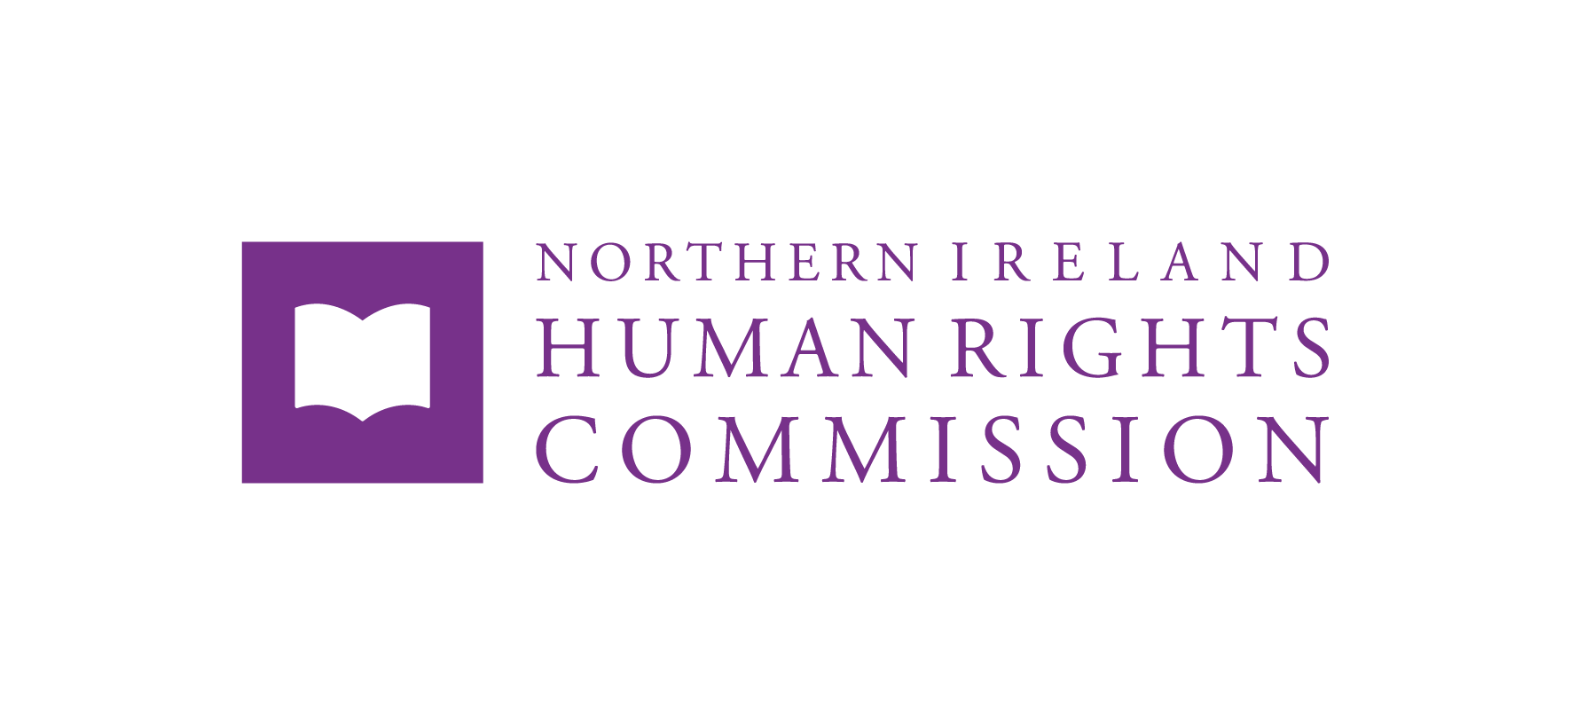

A Short Guide
Easy Read

Equality and Human Rights after Brexit:

The UK Government’s commitment under the Ireland/Northern Ireland Protocol

Article 2(1) of the Protocol

What is this document about?
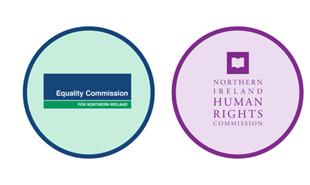
This document is from the Equality Commission for Northern Ireland and the Northern Ireland Human Rights Commission.
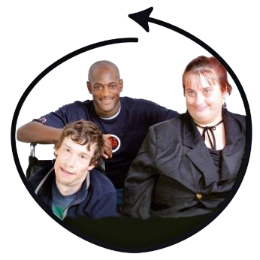
Both organisations help to protect and promote the rights that everybody in Northern Ireland (NI) have (and should have).

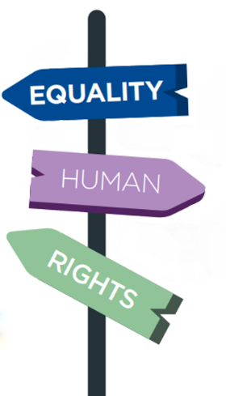

This document is about their new shared roles and responsibilities to help protect your equality and human rights after Brexit.
You can find out more about the information in this document and the work the Commissions do by contacting them. Their contact details are on the back of this document.
Hard words and what they mean
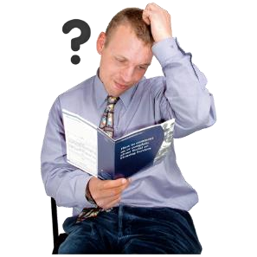
This is new information so here are some hard words and what they mean to help you understand. When a hard word is used in this document it is in bold.

Breach - when a law or agreement has been broken.
Commission - an organisation given special powers and responsibilities by a government to do an important job, like to protect and promote rights.
Commitment - a promise that must not be broken.
Discrimination - when a person or a group of people is treated unfairly because of differences such as disability, age, or gender.
Equality - everyone having the same chances to do what they can. Some people may need extra help to get the same chances.
European Union (EU) - a group of 27 European countries who make shared decisions about things like business and laws.
Belfast (Good Friday) Agreement - officially called the Belfast Agreement. Documents signed by the Irish and British governments in 1998 to help there be peace in NI after many years of fighting between communities. The B/GFA includes lots of the rights people in NI have.
Human Rights - freedoms and protections that every person has. They are about things everyone should be free to do, and harm everyone should be protected from.
Ireland/Northern Ireland Protocol (the Protocol) - a special agreement for NI after Brexit.

What is the UK Government’s commitment and why does it matter?
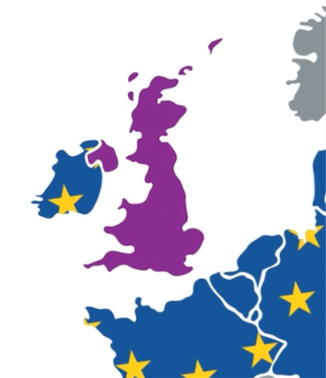
The United Kingdom (UK) left the European Union (EU) in 2020. This is known as Brexit.

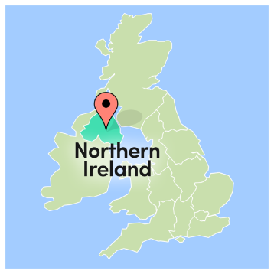
NI is part of the UK and has left the EU. NI is also part of the island of Ireland, and Ireland is still part of the EU.

For many parts of everyday life to be able to continue, such as business and travel across the island of Ireland, there needs to be special measures in place for NI after Brexit.

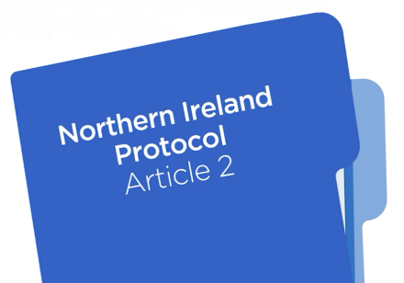
The special measures are part of the Brexit agreements and together they are known as the Northern Ireland Protocol. This document is about the part of the Northern Ireland Protocol called Article 2(1).
What rights are covered by the commitment?

Article 2(1) of the NI Protocol says that the UK government has made a commitment to make sure that people in NI do not lose certain equality and human rights because of Brexit.
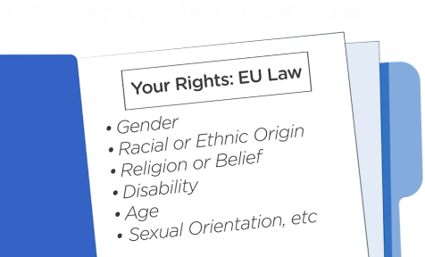
This means that the rights people in NI had before Brexit cannot be reduced. It also means that NI will keep up with any changes that the EU makes to the equality rights that people have. The UK’s commitment in Article 2(1) is about the rights that are written in the Belfast (Good Friday) Agreement.
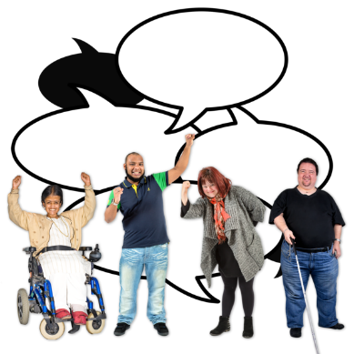
These rights include having freedom to choose things that matter to you, such as:

- Politics, including beliefs or taking part in politics
- Religion, including beliefs and practices
- Where you live.

Your rights also include protection from discrimination, so that you are not harmed or treated unfairly. This includes not being treated differently because of your beliefs, gender, race, age, or other personal characteristics.

Some of these rights are also linked to EU laws. These laws can impact other parts of your life, like employment, using health services, and the extra rights people have if they are disabled.
The commitment is in UK law. It applies to all of NI and to everyone who is protected by NI laws.
What is the role of the Equality Commission and the NI Human Rights Commission?
The Commissions have come together with new shared roles and responsibilities to make sure the UK Government meets its commitment under Article 2(1) of the NI Protocol.
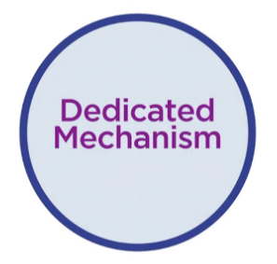
This is called the Dedicated Mechanism (DM). The Commissions can work as the DM together or on their own.

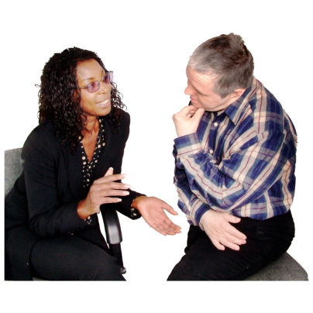
The DM has been set up to:
- Help everyone understand the commitment.
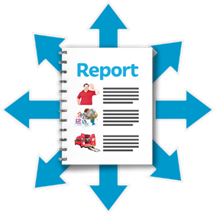
- Give advice to the government about the commitment.
- Review and report to the government about how the commitment is working.

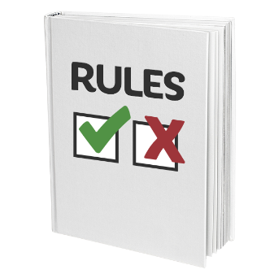
The DM also has special powers to make sure there has not been a breach of the commitment. This includes the power to:

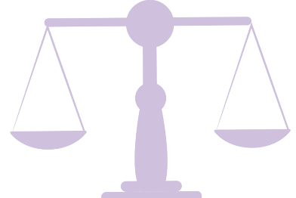
- Make a legal challenge if there is a possible or actual breach of the commitment.
- Give advice and support to people about making legal challenges.
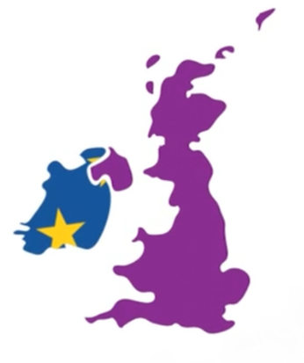
The Commissions will work with the Irish Human Rights and Equality Commission (IHREC) if there are issues related to the government’s commitment that impact all of the island of Ireland; for example, people who regularly travel across the border for work.

How can I make a challenge if I think there has been a breach of the commitment?


Individuals have the right to make legal challenges if they think there has been a breach of the commitment.

For example, if someone thinks the NI Assembly has made a decision that goes against the commitment, they can make a legal challenge.

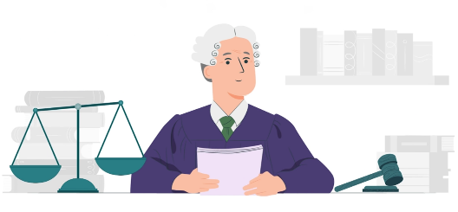
A legal challenge is dealt with by a court. The court will decide if there has been a breach of the commitment. The DM can give advice to people about a possible or actual breach of the commitment. They can, in some cases, support people to make legal challenges to a court.

The DM can take their own legal challenges and take part in court cases about a possible or actual breach of the commitment.

When can I make a legal challenge if I think there has been a breach of the commitment?
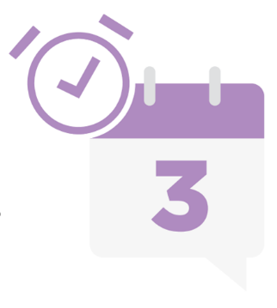
A legal challenge has to be taken to the court within 3 months of when a decision or action a person is complaining about has taken place.

Contacting the DM for advice or support about a legal challenge is not the same as making a legal challenge to a court.

How can I ask for advice or support if I think there has been a breach of the commitment?

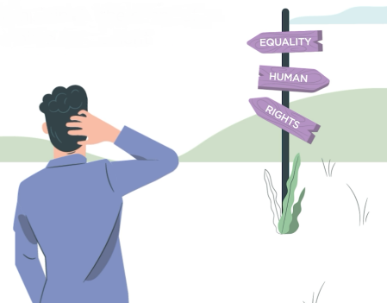
If you need advice or support, contact the DM as soon as possible after you think a breach of the commitment has taken place.



Further information

For further information and guidance, please contact:

Equality Commission for NI  DMU@equalityni.org  028 9050 0600  Equality House,  7-9 Shaftesbury Square,  Belfast  BT2 7DP  www.equalityni.org/brexit  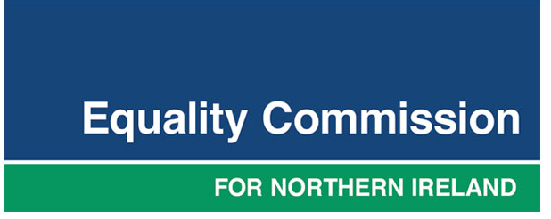 | NI Human Rights Commission  info@nihrc.org  028 9024 3987  4th Floor Alfred House,  19-21 Alfred Street,  Belfast  BT2 8ED  www.nihrc.org/human-rights-after-brexit  

August 2021

