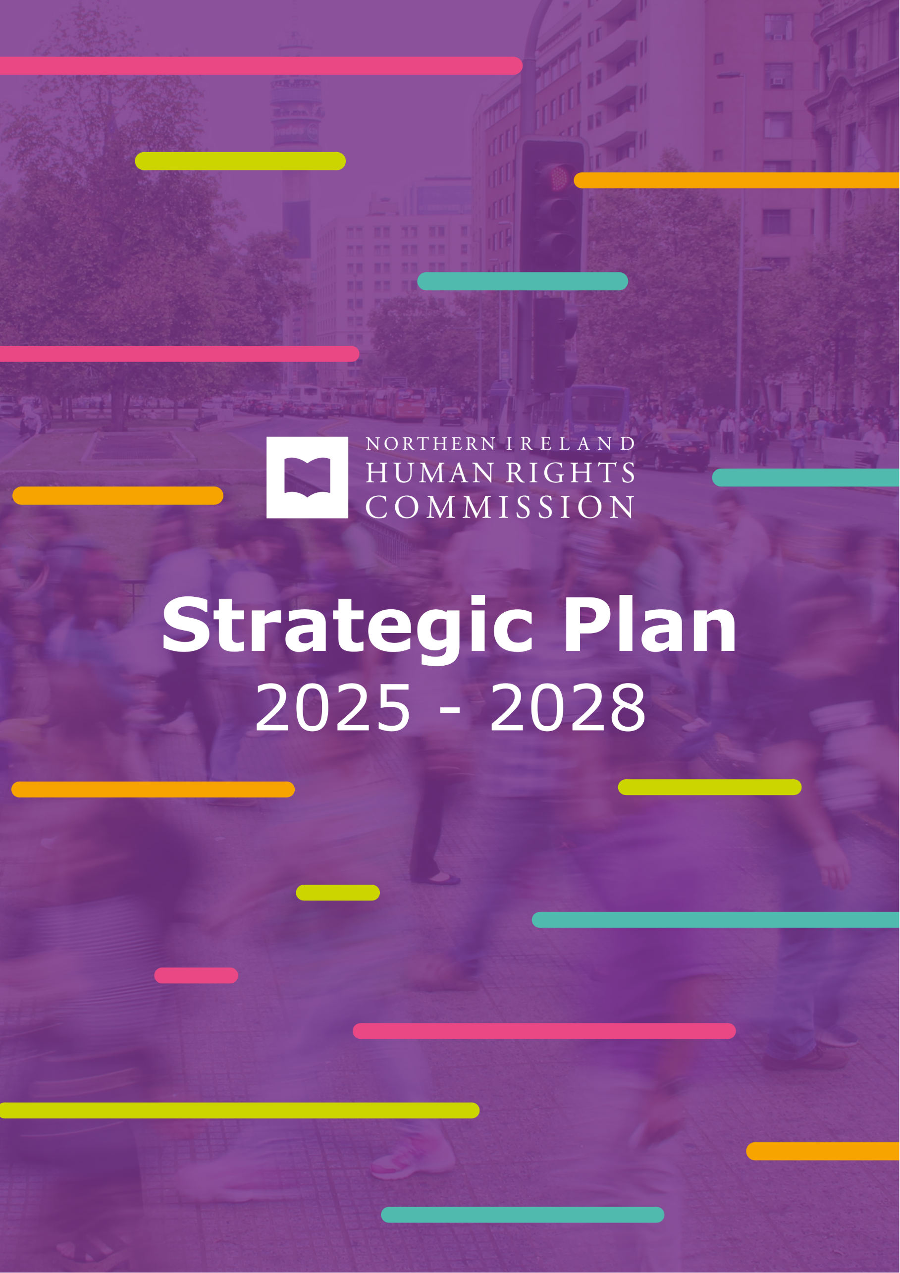


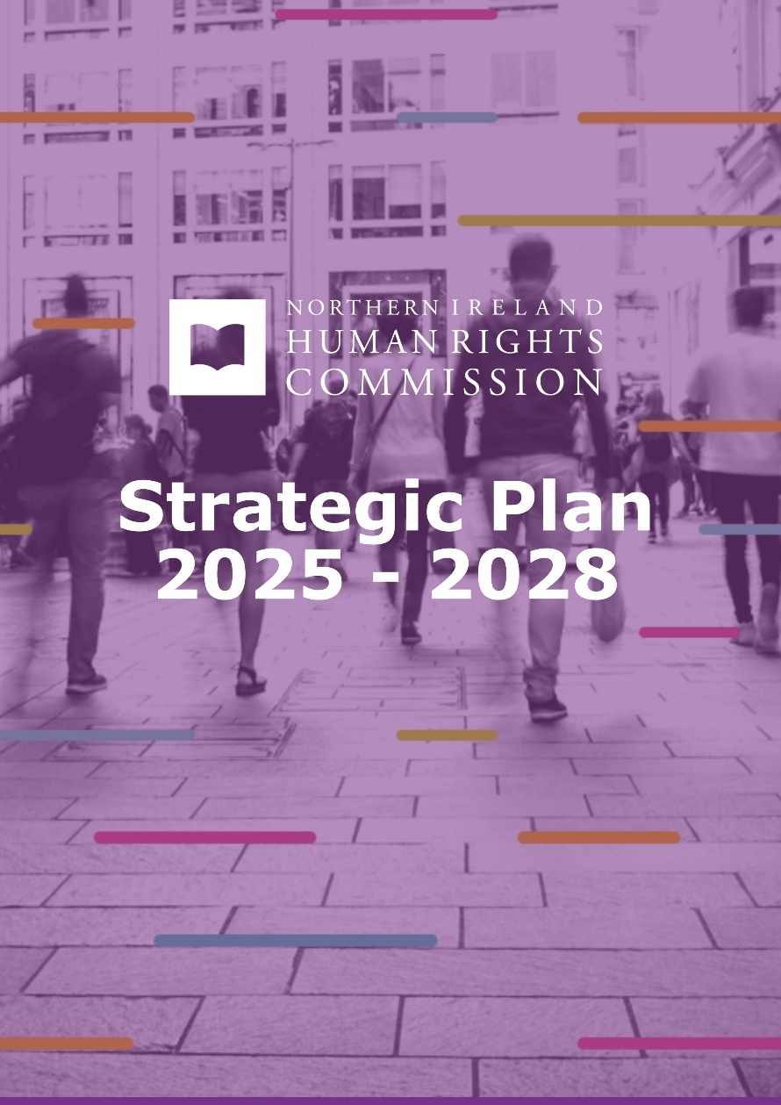


Strategic Plan
2025 – 2028

Foreword
I am pleased, on behalf of the Northern Ireland Human Rights Commission, to introduce this Strategic Plan for the period 2025–2028. It reflects our determination to promote and protect human rights for every person in Northern Ireland, regardless of status or background. Promotion and protection go hand in hand. By promoting the value of universal human rights, we strengthen adherence to fundamental human rights standards. Some of our work can be pre-planned, some will require a spontaneous response to events. This plan enables us to do both.

We are still challenged by a lack of adequate resources but are hopeful that will change soon. This strategic plan is being published as we await a formal response from the Secretary of State for Northern Ireland regarding two independent reviews of the Commission. We look forward to securing a budget settlement, which we hope will go some way to address the long-overdue increase in capacity needed for the Commission. As a National Human Rights Institution, we want to deliver greater impact for everyone in Northern Ireland.

In the meantime, we make the very best use of everything we have to achieve our objectives. First, greater prioritising and embedding of human rights in law, policy and service delivery. Two, more people, communities and organisations understand and respect human rights. Three, effective access to justice and remedies for people and communities who have their human rights violated or abused. Four, to be a learning organisation, improving our skills to achieve the greatest impact. And five, effective and efficient delivery of our corporate obligations as a public authority.

This plan is informed by the statutory mandate, set out in our founding legislation, the Northern Ireland Act 1998 and by the UN Paris Principles which set the international standards for national human rights institutions. It also reflects the values that guide our work—independence, participation, effectiveness, inclusion and partnership.

We encourage you to read the full document, as it sets out our plans in full. I would like to acknowledge the input made by my colleagues, staff and commissioners, who go above and beyond. Equally important are the stakeholders and partners who work with us - helping us to develop, year on year, offering us encouragement and challenging us when that is necessary.

We have listened and reflected upon what our stakeholders and partners have told us, but we want to hear more over the next three years. Please continue to tell us what you think about our work and help us fulfil our obligations as Northern Irelands Human Rights Commission. We are here for everyone, and we will continue to improve to serve everyone.

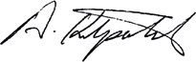

Alyson Kilpatrick
Chief Commissioner
Northern Ireland Human Rights Commission

Strategic Plan 2025-2028

The Northern Ireland Human Rights Commission (the Commission) aims to influence the development of a society where the human rights of everyone are protected. We will ensure efficient and effective use of public resources. Our work will have impact across Northern Ireland and support those who need us most.

Our Vision
A society that respects human rights values and standards to achieve equality, peace and justice.

Our Purpose
To protect and promote the human rights of everyone in Northern Ireland.

Our Principles


Independence
We value and will protect our independence; we will act professionally and with integrity; we will make all our decisions based on objective evidence.

Participation
We will empower people
to participate to the fullest extent possible in decisions that affect their human rights.



Effectiveness
We will work to ensure human rights protections are reflected in laws, policies and practices; we will work to ensure meaningful remedies for human rights violations and abuses.

Inclusion
We will oppose any form of discrimination or prejudice and support victims.

Partnership
We will work to achieve the greatest impact by partnering with communities and our stakeholders.

Our Strategic Objectives for 2025-2028

1
Greater prioritising and embedding
of human rights in law, policy
and service delivery.

2
More people, communities and organisations
understand and respect human rights.

3
Effective access to justice and remedies
for people and communities who have their
human rights violated or abused.

4
To be a learning organisation, improving
our skills to achieve the greatest impact.
5
Effective and efficient delivery of our corporate obligations as a public authority.

Our Priorities

We will aim to ensure:
- The Commission’s advice and research influences decision-makers to take actions that progress the protection and enjoyment of human rights.
- Law and policy makers at all levels, consider and address the human rights impacts identified through our advice, research, investigations and reports to the United Nations and Council of Europe.
- The Commission’s promotional activities increase understanding and awareness of human rights in Northern Ireland.
- The Commission’s education activities increase the capability of individuals, communities and organisations to promote and protect human rights.
- The Commission delivers effective support to individuals and groups who seek assistance for reported human rights violations and abuses.
- The Commission delivers continuous improvements in accordance with its mandate and the Paris Principles (United Nations General Assembly Resolution 48/134).
- Staff and Commissioners gain knowledge and skills that improve effectiveness and efficiency.
- The Commission has good corporate governance, effective systems and arrangements in place to provide assurance on risk management and internal control.
- The Commission operates in accordance with HM Treasury guidance on Managing Public Money.
- The Commission remains publicly accountable for its services.

How we will measure progress

Strategic Objective 1

Greater prioritising and embedding of

human rights in law, policy and service delivery.

We will aim achieve this objective by providing advice and research that influences decision-makers to take actions that progress the protection and enjoyment of human rights. We will engage with law and policy makers at all levels, to consider and address the human rights impacts identified through our advice, research, investigations and reports to the United Nations and Council of Europe.

Progress will be measured by:

- Instances of the Commission participating in working groups or regular engagement with government, legislatures and other public authorities to advance human rights.

- Instances of the Commission providing government and other public authorities with advice or publishing research (upon request or unsolicited).
- Instances of civil society organisations seeking advice from the Commission in engagement with public authorities.

- Instances of the Commission providing oral evidence to parliamentary Committees or officials (or analogous e.g. public inquiries).
- Instances of engagement by public authorities (including department officials) with the Commission's training and education programmes.

- Instances of the Commission's advice and recommendations reflected in legislative processes (including amendments to Bills).

- Instances of UK Parliament and NI Assembly inquiry reports and letters that reflect or cite the Commission's advice.

- Instances of public authorities adopting advice received from the Commission when developing and implementing policies.

- Instances of the Commission's treaty reporting recommendations reflected in committees concluding observations, reports (including United Nations Special Rapporteurs) and activities.

- Instances of international organisations and networks engaging with or seeking advice and input from the Commission.
Strategic Objective 2

More people, communities and organisations

understand and respect human rights.

We will aim to achieve this objective by supporting promotional activities that increase understanding and awareness of human rights in Northern Ireland. Through our education activities the Commission will seek to increase the capability of individuals, communities and organisations to promote and protect human rights.

Progress will be measured by:
- Instances of the Commission represented in print/broadcast media and third party reports (including academic articles).
- Instances of social media engagement.
- Levels of engagement with Commission events.
- Levels of website traffic.
- Levels of engagement with the Commission's activities (including measurement of satisfaction and reports of increased understanding).

Strategic Objective 3

Effective access to justice and remedies

for people and communities who have their

human rights violated or abused.

We will aim to achieve this objective by delivering support

to individuals and groups who seek our assistance and successfully exercising the Commission’s legal and investigatory powers.

Progress will be measured by:

- A majority of applications by the Commission to courts and tribunals for leave to appear or provide written submissions are granted.

- Instances of the Commission's submissions reflected in the judgment of the matter.

- The Specialised Committee on issues related to the implementation of the Protocol on Ireland/Northern Ireland of the European Union Withdrawal Agreement accepts referrals and reflects advice provided by the Commission.

- Instances of support provided to individual clients.

- Instances of investigations by the Commission resulting in actions by the UK government, NI Executive or public authorities to improve respect and protection of human rights.

Strategic Objective 4

To be a learning organisation, improving our

skills to achieve the greatest impact.

We will aim to achieve this objective by ensuring continuous improvements when delivering the Commission’s mandate and operating in accordance with the Paris Principles (United Nations General Assembly Resolution 48/134). Our staff and Commissioners will be supported to gain knowledge and skills that improve effectiveness and efficiency.

Progress will be measured by:

- The Commission retains its United Nations accreditation with Global Alliance of National Human Rights Institutions and effectively seeks to address any recommendations.

- Instances of the Commission benefitting from learning and good practices of other National Human Rights Institutions delivering their mandates or through the initiatives of regional and international bodies (including the European Network of National Human Rights Institutions and Global Alliance of National Human Rights Institutions).

- Instances of facilitating ongoing learning opportunities for staff and Commissioners.

Strategic Objective 5

Effective and efficient delivery of our corporate

obligations as a public authority.

We will aim to achieve this objective by ensuring there is good corporate
governance, effective systems and arrangements in place to provide
assurance on risk management and internal control. We will operate in accordance
with HM Treasury guidance on Managing Public Money and remain
accountable for our services.

Progress will be measured by:
- Relevant internal and external audits addressing corporate governance receive a satisfactory rating.

- A majority of governance matters and risks reported to the Audit and Risk Management Committee are mitigated or resolved.

- Relevant internal and external audits addressing financial management receive a satisfactory rating.

- The Commission operates within the limits of its statutory authority and any delegated authority, as well as in accordance with any other conditions or HM Treasury guidance relating to the use of public funds.

- The Commission's Annual Report and Account are agreed and signed off by the National Audit Office.

- A majority of required monthly financial and workforce management reports are submit on time.

- The Commission meets Government target of paying 90% of undisputed invoices within five working days.

- Instances of non-compliance with any open government or transparency policies, initiatives and guidance issued by the NI Office, HM Treasury or Cabinet Office.

- The majority of Freedom of Information Act are responded to within statutory time limits.

- The Commission complies with its equality and good relations duties and meets any reporting requirements.

- The Commission responds promptly and engages transparently in response to any complaints made to the Parliamentary Ombudsman.

- All personal data held by the Commission is retained in accordance with the General Data Protection Regulation as it applies in the United Kingdom, tailored by the Data Protection Act 2018 and personal data related incidents reported formally to the Information Commissioner’s Office, if applicable.

www.nihrc.org | info@nihrc.org | +44 (0)28 9024 3987 4th Floor, Alfred House, 19-21 Alfred Street, Belfast, BT2 8ED






